PROJECT

NEW YORK CITY TAXI FARE PREDICTION

PROJECT CONTRIBUTORS

Fernando Rios

Hassan Ouanir

Ian Kavuma

**Introduction:**

In this project, the task is to predict the taxi fare in New York City given the information about number of passengers, pickup and dropoff locations, and the pickup datetime. The NYC TAXI FARE dataset consists of 55 million training records since 2009 and 9914 test records which represent taxi trips in New York.

To achieve this goal predicting NYC Cab fare, we split this project into three parts

**Part I**: **Data pre-processing and** **Exploratory Data Analysis (EDA)**

* Data cleaning, Data Exploration
* Data visualization, and
* Feature engineering, Feature Selection

**Part II**: **Predictive Modelling**

* Model Evaluation

**Part III: Submission**

**Part I: Data pre-processing and Exploratory Data Analysis (EDA)**

**Data Description and pre-processing**

The NYC Taxi fare dataset is obtained from Kaggle.com, to begin the data analysis we imported

the project files:

* Train.csv: Input features and target fare_amount values for the training set (about 55M rows). We used 1.5 Million.
* Test.csv: Input features for the test set (about 10K rows). Your goal is to predict fare_amount for each row.
* Sample_submission.csv - a sample submission file in the correct format (columns key and fare_amount).

**Training dataset**

The file train.csv has the input features and target fare_amount values (about 55M rows). We imported the data and used 1.5 Million.

Data type of features:

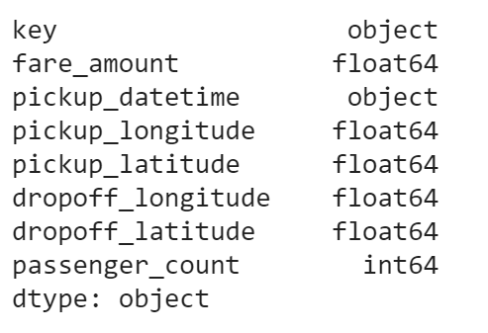

Description of features

|  |  |
| --- | --- |
| **Feature** | **Feature Description** |
| key | ID: datetime unique identifier |
| fare_amount | Value to predict |
| pickup_datetime | Date and time of when trip started |
| Pickup_longitude | Longitude of the starting point of the trip |
| Pickup_latiture | Latitude of the starting point of the trip |
| Dropoff_longitude | Longitude of the end point of the trip |
| Dropoff_latitude | Latitude of the end point of the trip |
| Passerger_count | Number of riders in a trip |

**Some questions we are trying to answer:**

1. Distance of a trip, does more distance mean higher price?
2. Time of travel, is the fare higher during some intervals of the day like during traffic or rush hours?
3. Is there a difference traveling weekends and weekdays does fare differ?
4. Do trips from and to airports fixed?
5. Does pickup and dropoff area matter in influencing the fare?
6. Does price go up or drop based on number of cabs available?

**Data cleansing**

For this section, we used various steps to clean up the data from unnecessary values and used looked at relationships among features.

* We first check the data for any missing or null values and remove them.

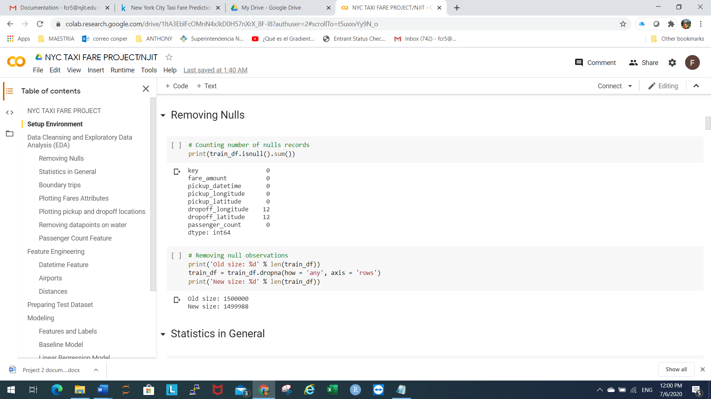

* Next is to look and investigate some basic statistics of each feature (figure 1) involved in this data set.

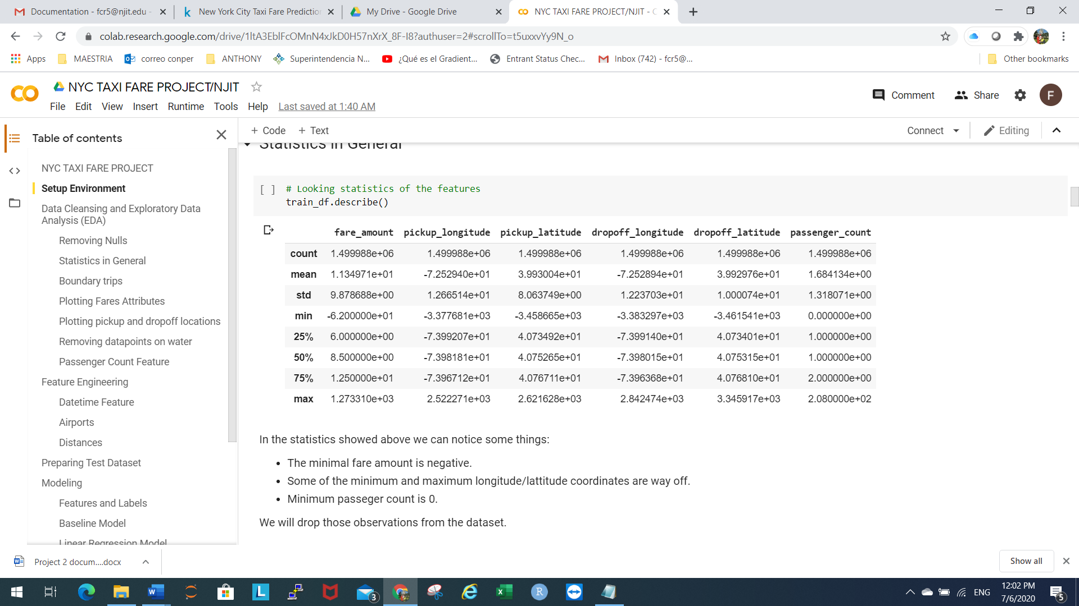

Figure 1: Summary statistics of NYC Fare prediction dataset

* Beginning with fare amount, we look at the minimum price of -62 $. This observation means that the data contains some negative fares, but we know that a fare cannot be negative.
* A trip at least costs a base fare which is 2.5$. Hence, we need to remove these negative fares from the data

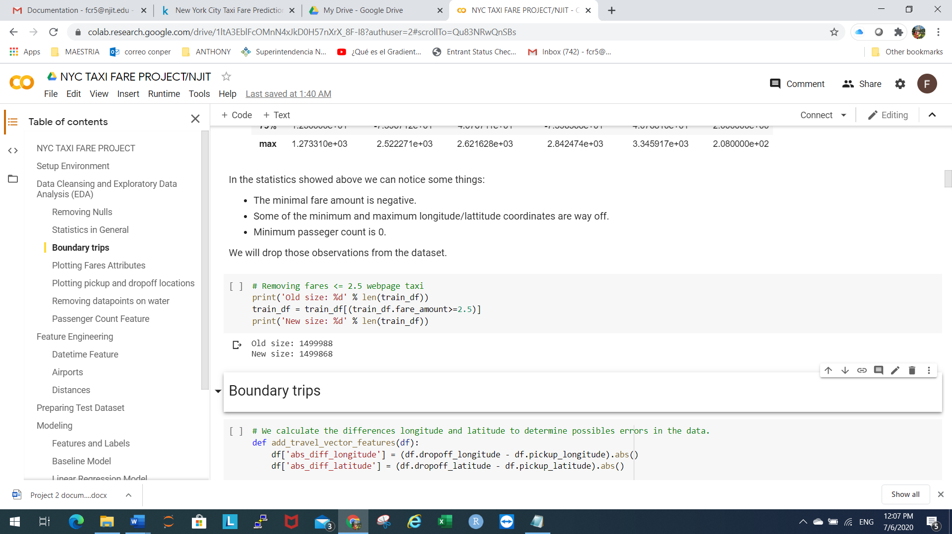

Now we move into checking longitude/Latitude values. A simple look at the table (figure 1), some values seem to be outside of the New York City borders. However, this is a simple check, to be certain we must do some more analysis. For this we employ another way that is looking at absolute distance difference in both latitude and longitude, we need to create new features with these differences:

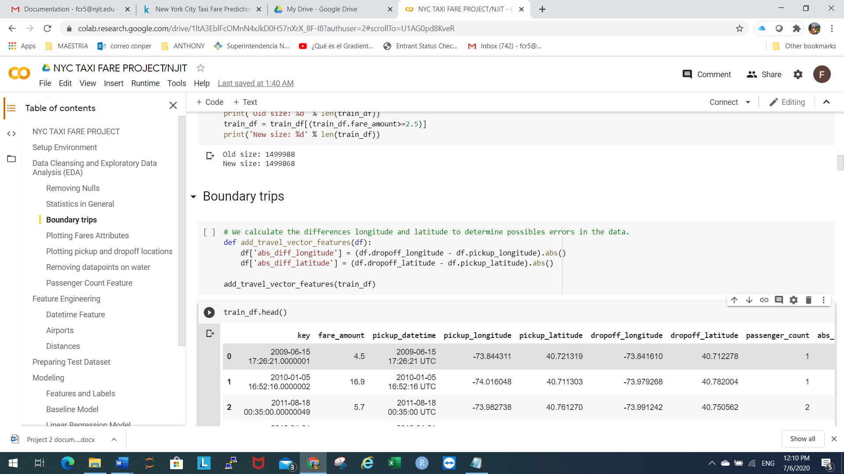

Then, we plot a scatter plot of absolute difference in latitude vs absolute difference in longitude (figure 2). We can see that there are many trips with difference in both longitude and latitude that are more than 5 degrees which is about 300 miles. Thus, we need to take out the values of longitude/Latitude that are outside NYC City boundary box.

Using online NYC map we came up with a boundary of (-74.311, -72.16, 40.5389, 41.80)

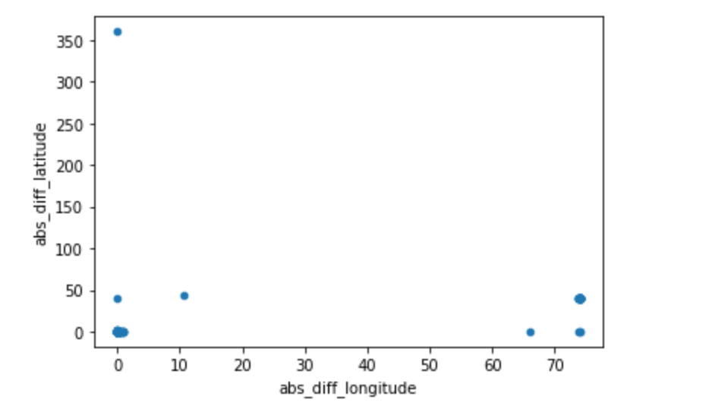

Figure 2: Plot of abs diff latitude vs longitude

Using this boundary box, we filtered all the datapoints that are outside New York City boundary.

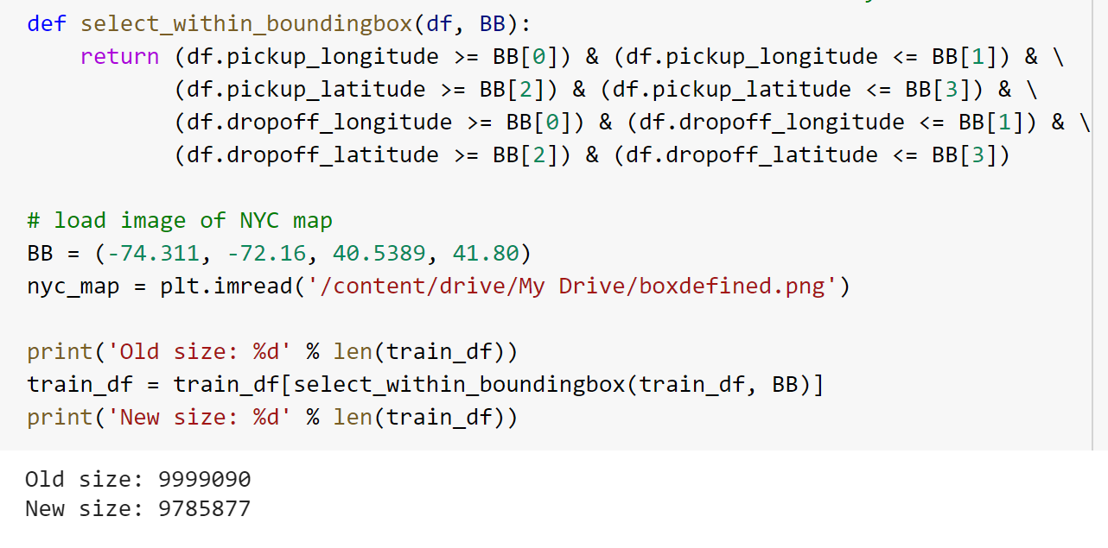

After taking care of the boundary, we check that only the data points inside the box remain

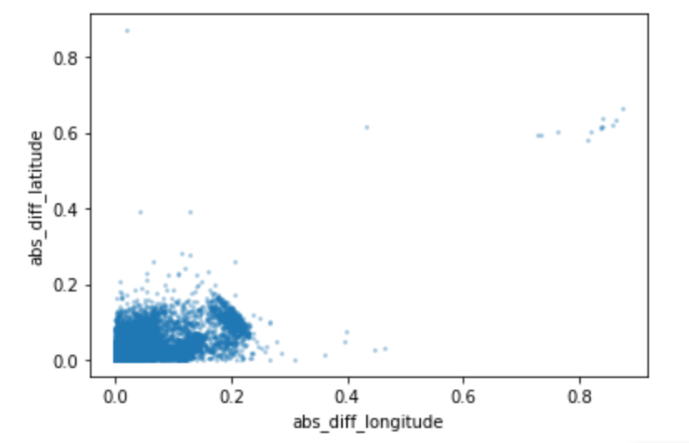

In the picture we can observe that there are some datapoints spread, it could be some fixed trips out of the NYC area.

**Water Data points**

We can clearly see that trapped all the trips we needed within the NYC boundary. We now need to take care of the data points that are in waters of the New York City. For this we create a function remove_data_points_from_water to help cleaning up the data values that are on water that we don’t need. We do that by bring the New York City map where we already know where the water, we plot the obtained data points we cleansed already in previous steps on the map.

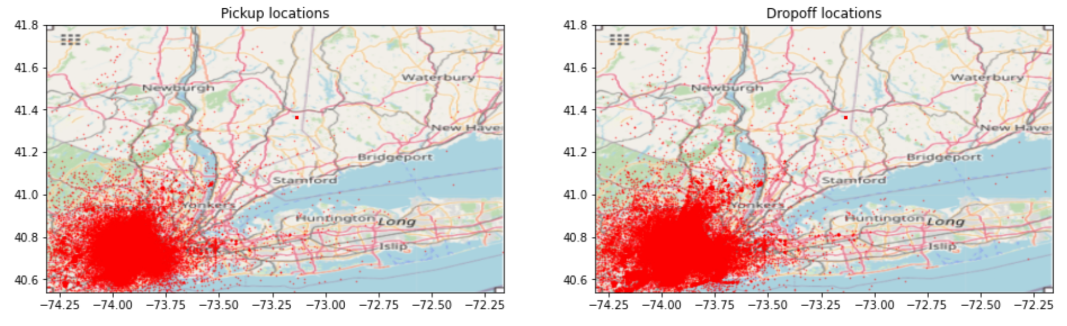

The approach is basically to take out the areas of water we already know from the data points.

We get the following graphic after removal of all the unnecessary points in water.

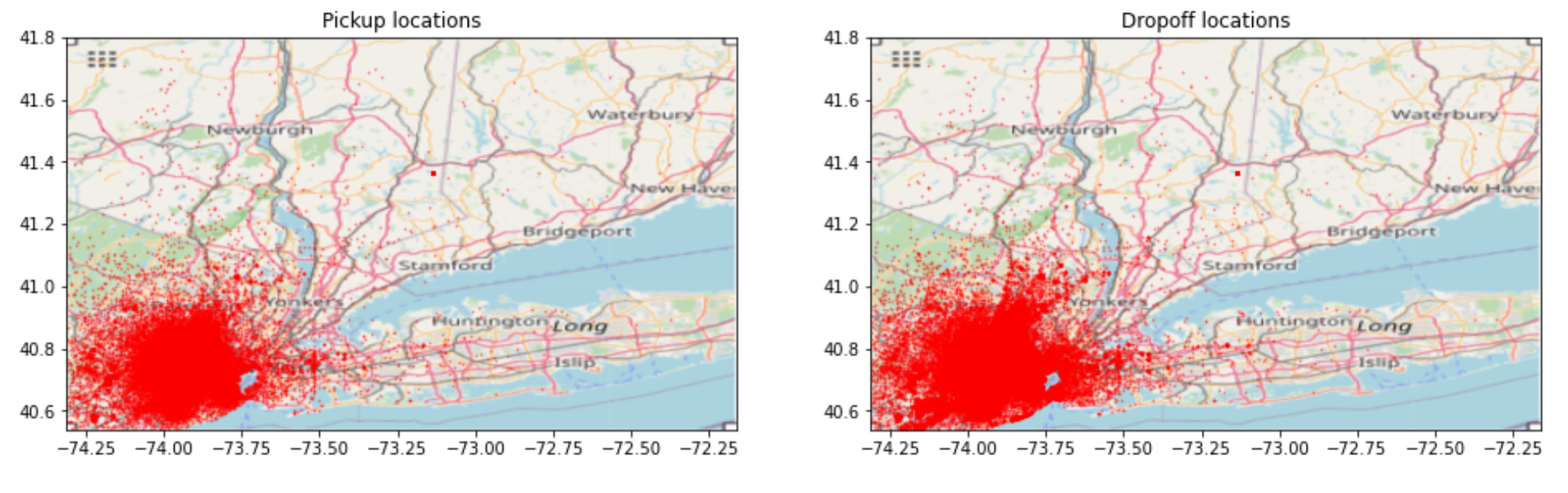

Next, we move to examine to the variable passenger_count. Again, from basic statistics,

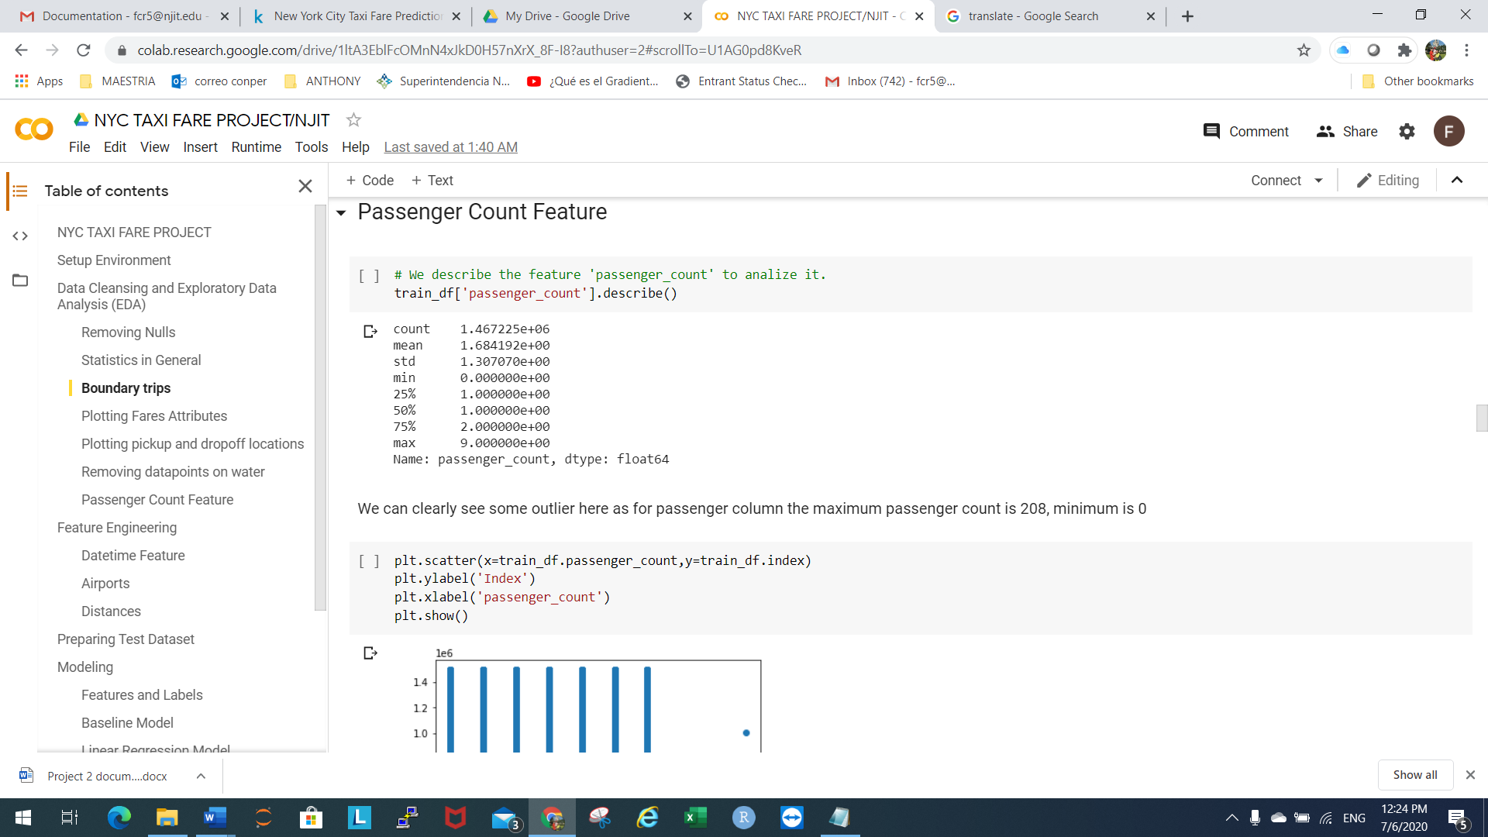

We can detect that some values are off. We see that the minimum number of passengers is 0 and maximum number of passengers is 9. These two values are clearly outliers since the Taxi trip must at least have 1 passenger. In addition, the maximum cab occupancy is 6 passengers. We must purge these values from the data set.

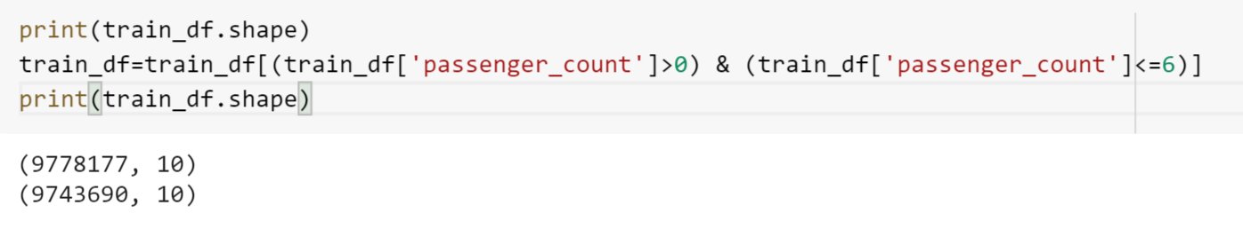

**Airport**

For this we use a heatmap of pickups and drop-offs within NYC. The approach is to use the datapoints plot on the map and our knowledge of airports locations to see how the data behaves. We look into both drop-offs left side graph and pickups right side graph, we can see dense pickups and drop-offs around JFK, La Guardia, Newark airports.

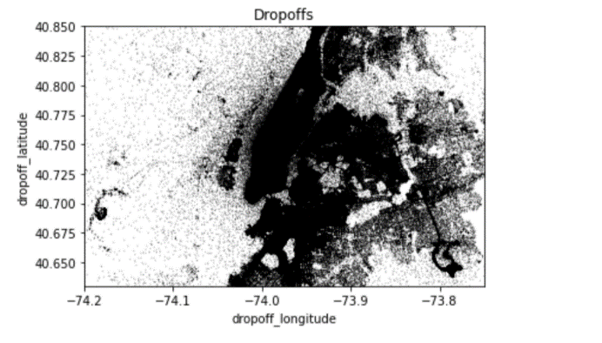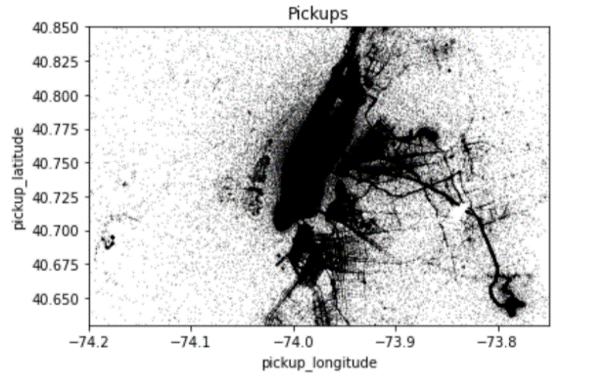

We investigated some data analytics about fare amount to get some insight of cost of trip trends.

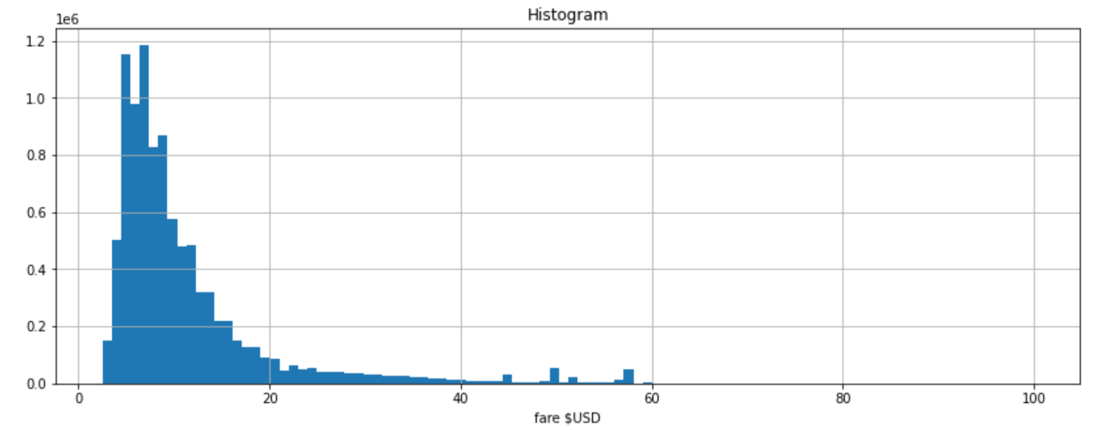

This graphic clearly shows the expectation, that is majority of fares are below 30$ benchmark. Though there are some fare between 40$ to 60 $. We can tell that the more the price the less trips. Which is to be expected. The expensive trips are not as dense as smaller trips.

In the same manner we also check the distance of the ride. First we calculate the distance of the trip using a distance metric that use coordinates longitude and latitude.

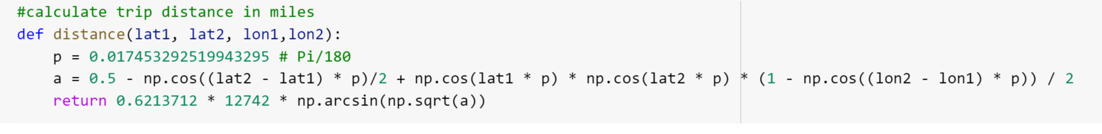

After obtaining the distance of each trip as vector, we plot those distance to see the frequency.

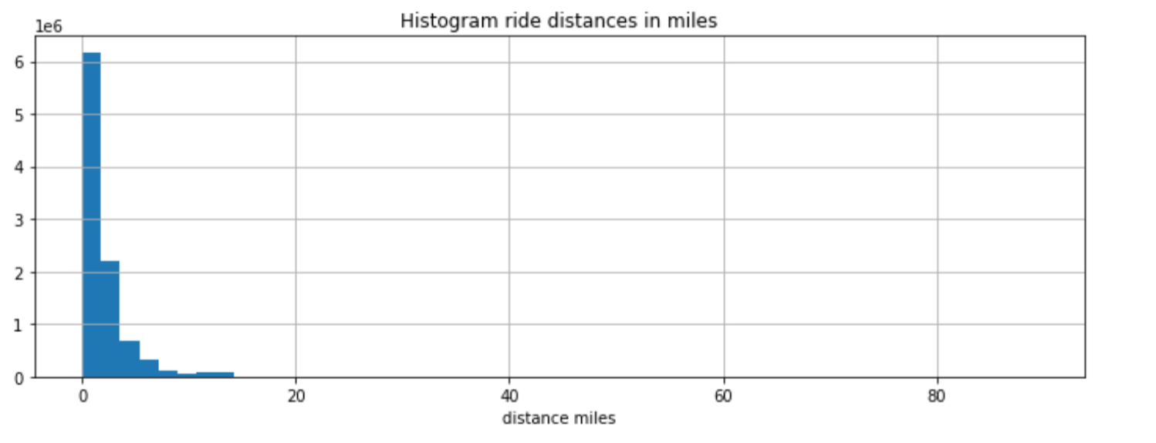

From this we can clearly see the trend. The most common kind of trips are short rides. We notice a small peak at 13 miles. This peak could be due to trips from/to airports perhaps.

**Feature Engineering:**

We consider the datetime feature and ask some questions:

1. Does the number of passengers affect the fare?
2. Does the date and time of pickup affect the fare?
3. Does the day of the week affect the fare?
4. Does the distance travelled affect the fare?

First, we convert the pickup_datetime column into data type “datetime” and split the field into:

* Year
* Month
* Date
* Hour
* Day of the week

Using this extraction, we try to answer our questions about how datetime effects the fare.

**For number of passengers:**

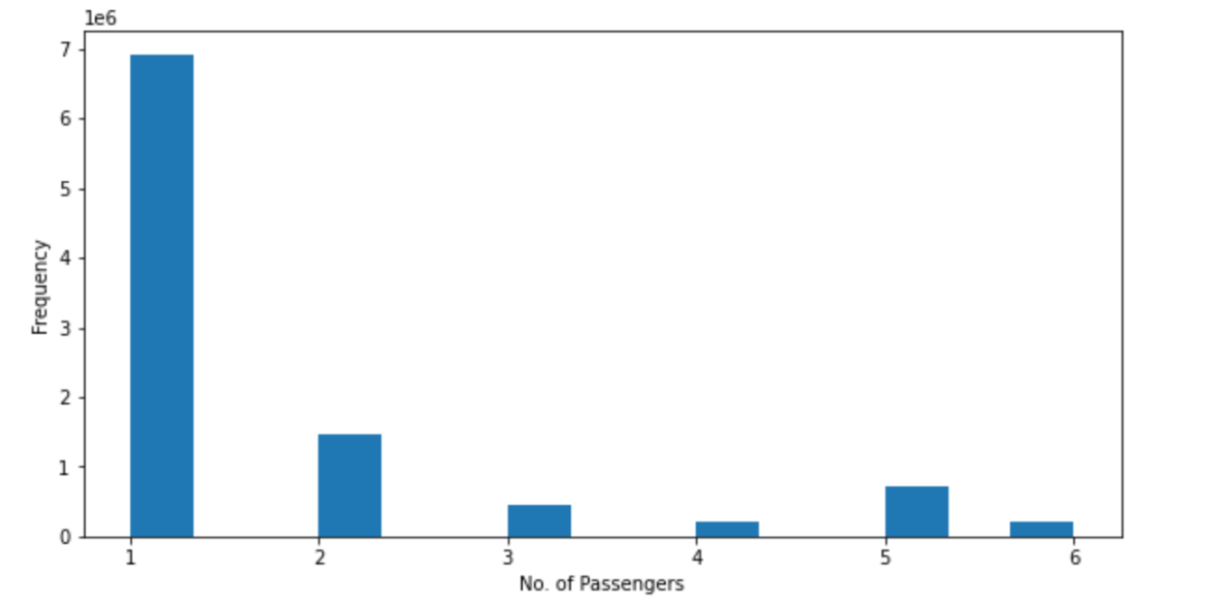

From this graph we can tell that the most common kind of trip is a trip with a single passenger also the highest fares come from single passengers.

**Trips throughout the month:**

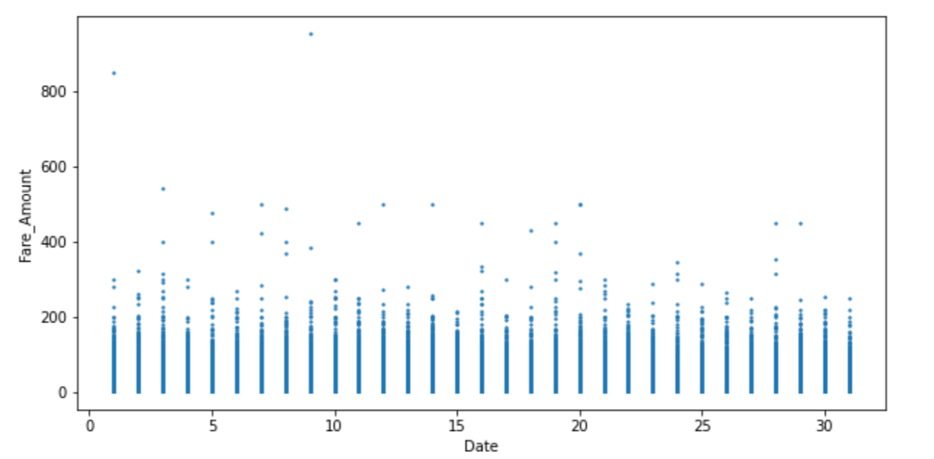

Trips around the month seem to be uniform and that there is no particular pattern, the 12th day seems the only off set to this uniformity where fare was highest.

**Time or hour of pickup**

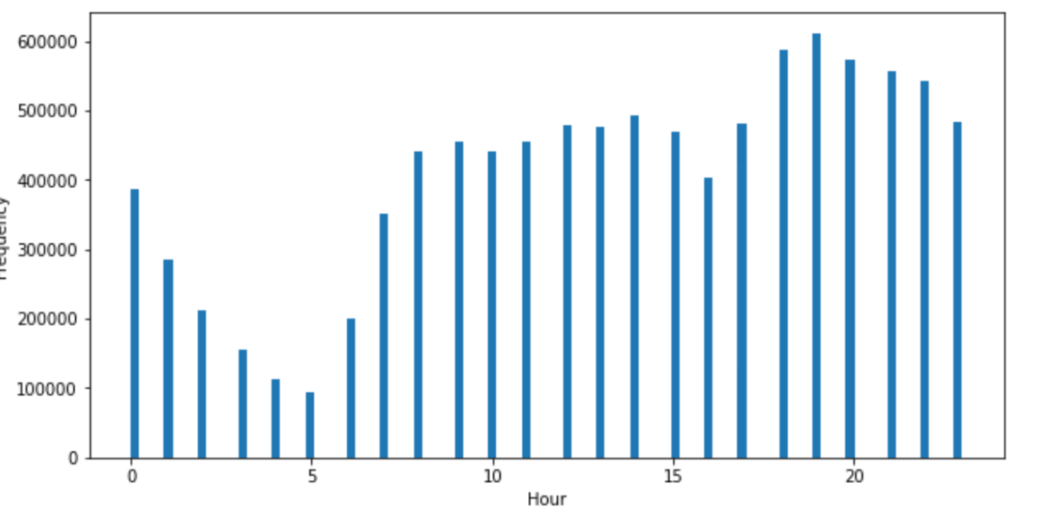

For the particular timing of pickup during the day, there seems to be some patterns. At 5 AM in the morning there is drop of rides. At 7 PM there is also another drop, this clearly means the hour has clear affects on the number of rides and therefore the cost of the trip

**Distance affects**

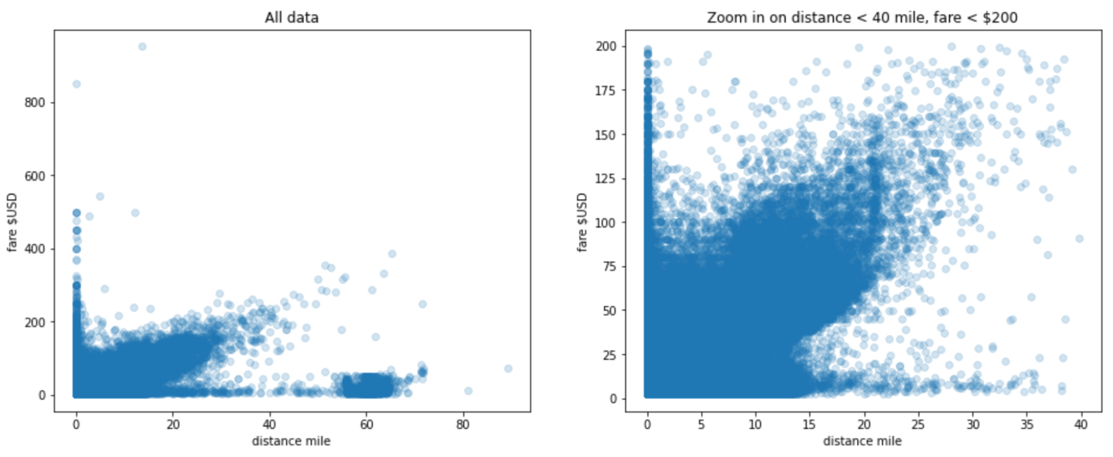

Well the distance is definitely going to be a factor to the trip without the need of any analytics. But this graphs gives a good visual, short trips are more common here.

**Engineered Features**

Based on all the above information we decided to make new features out of datetime feature such as year, month, day, hour, day of the week.

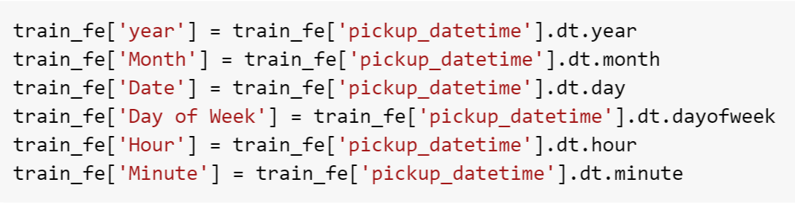

We also added the distance feature as it big factor for the fare amount

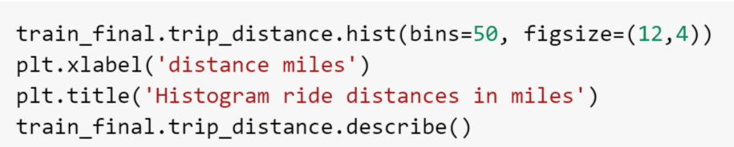

**Test dataset**

We prepared the test dataset basically creating the same features like in training dataset.

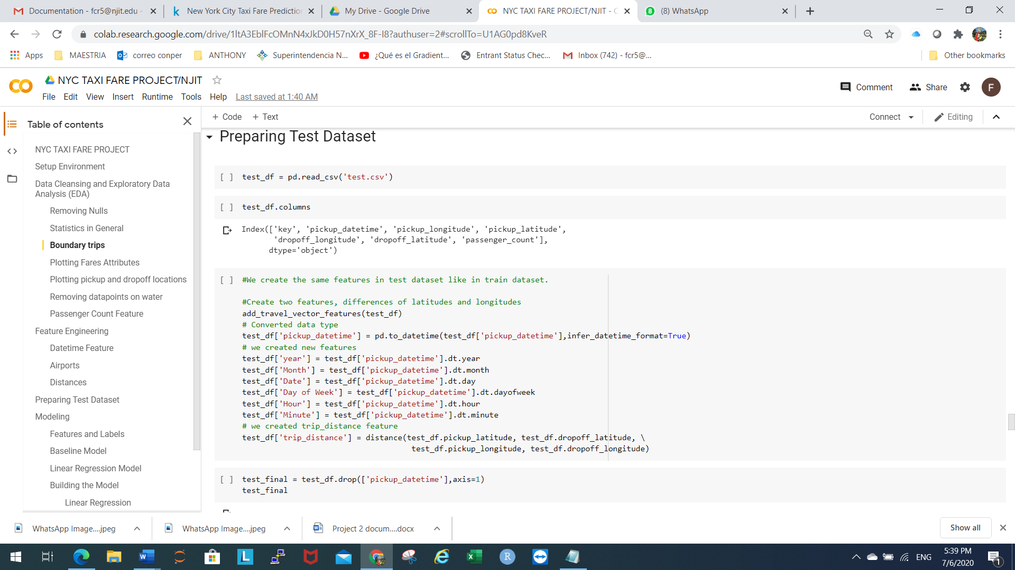

**Part II: Predictive Modelling:**

In previous part we got the data ready by cleaning it and analyzing relationships between variables. We understood various features that will importance role on the taxi fare.

We will now begin building our predictive machine learning models to predict the taxi fare. We also look at the significance of feature engineering in this process.

**Roadmap:**

Now that we put our data through cleaning and analysis process, our data is ready for some model building. Everything we will be doing in this phase hinges on how well we did the previous phase that the quality of our data preprocessing. The following are the steps we will take during this phase

* Prepare data for modeling (split data)
* Create a baseline prediction
* Build models

**Data Preparation:**

We divided our data into training data and testing data sets. This step is crucial for evaluation of our model later on. The test size chosen is 25%.

The testing data set will help us see how the model is fitting the training dataset and how it works with the data that is not seen yet. This in turn will tell if the model is overfitting or underfitting. Overfitting refers to the situation where the training error is low, but the testing error is high. For this project we chose a 1/4 of data as validation while the 3/4 goes for the training.

**Baseline Model:**

In this model, we look for the solution our problem without applying any machine learning techniques. Later, we will build on this model and use machine learning methods to improve the model. The simpler way to this is to take averages and use mean square error to validate for regression and for the classification, we just look at the most frequent value.

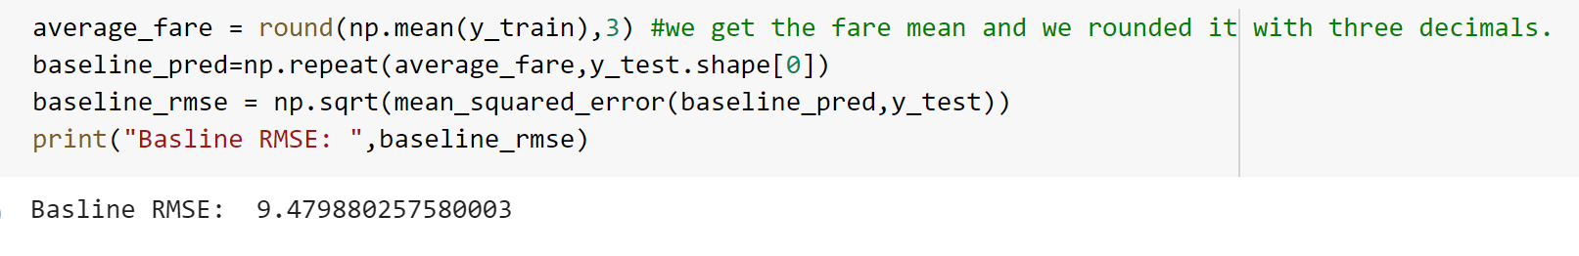

We got and RMSE of 9.42, so we hope the models that we build will give us an RMSE lower than 9.42.

**Model Building and Evaluation:**

For this stage, we use the final data we obtained after feature engineering. To understand the models, we created and evaluate them. We will use the following Machine Learning algorithms:

* Linear Regression
* Random Forest
* Light GBM

1. **Linear Regression:**

The linear regression will try to find or identify a line that best fits the data. The process uses a linear relationship between the target and the predictors. This algorithm is not very flexible and has very high bias.

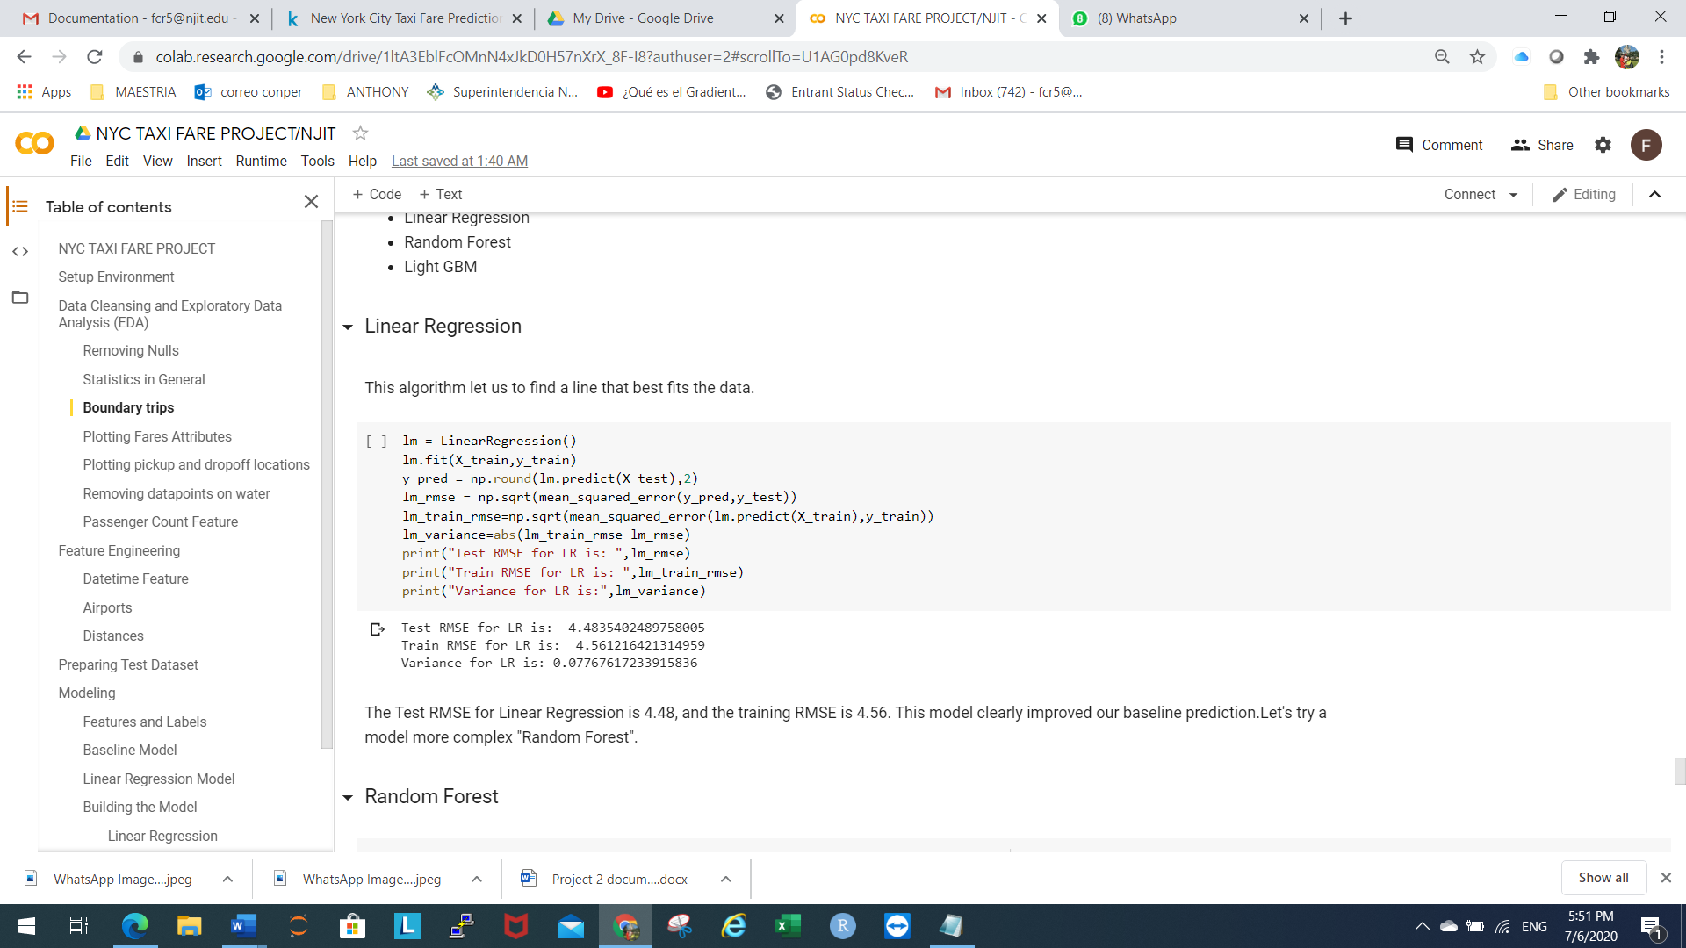

The linear regression resulted in a RMSE of 4.48 for testing and RMSE of 4.56 for training. Comparing this result with baseline model, we find a good improvement.

1. **Random Forest**

We are expecting that the random forest can fit the data better. This algorithm is more complex than linear regression and has lower bias.

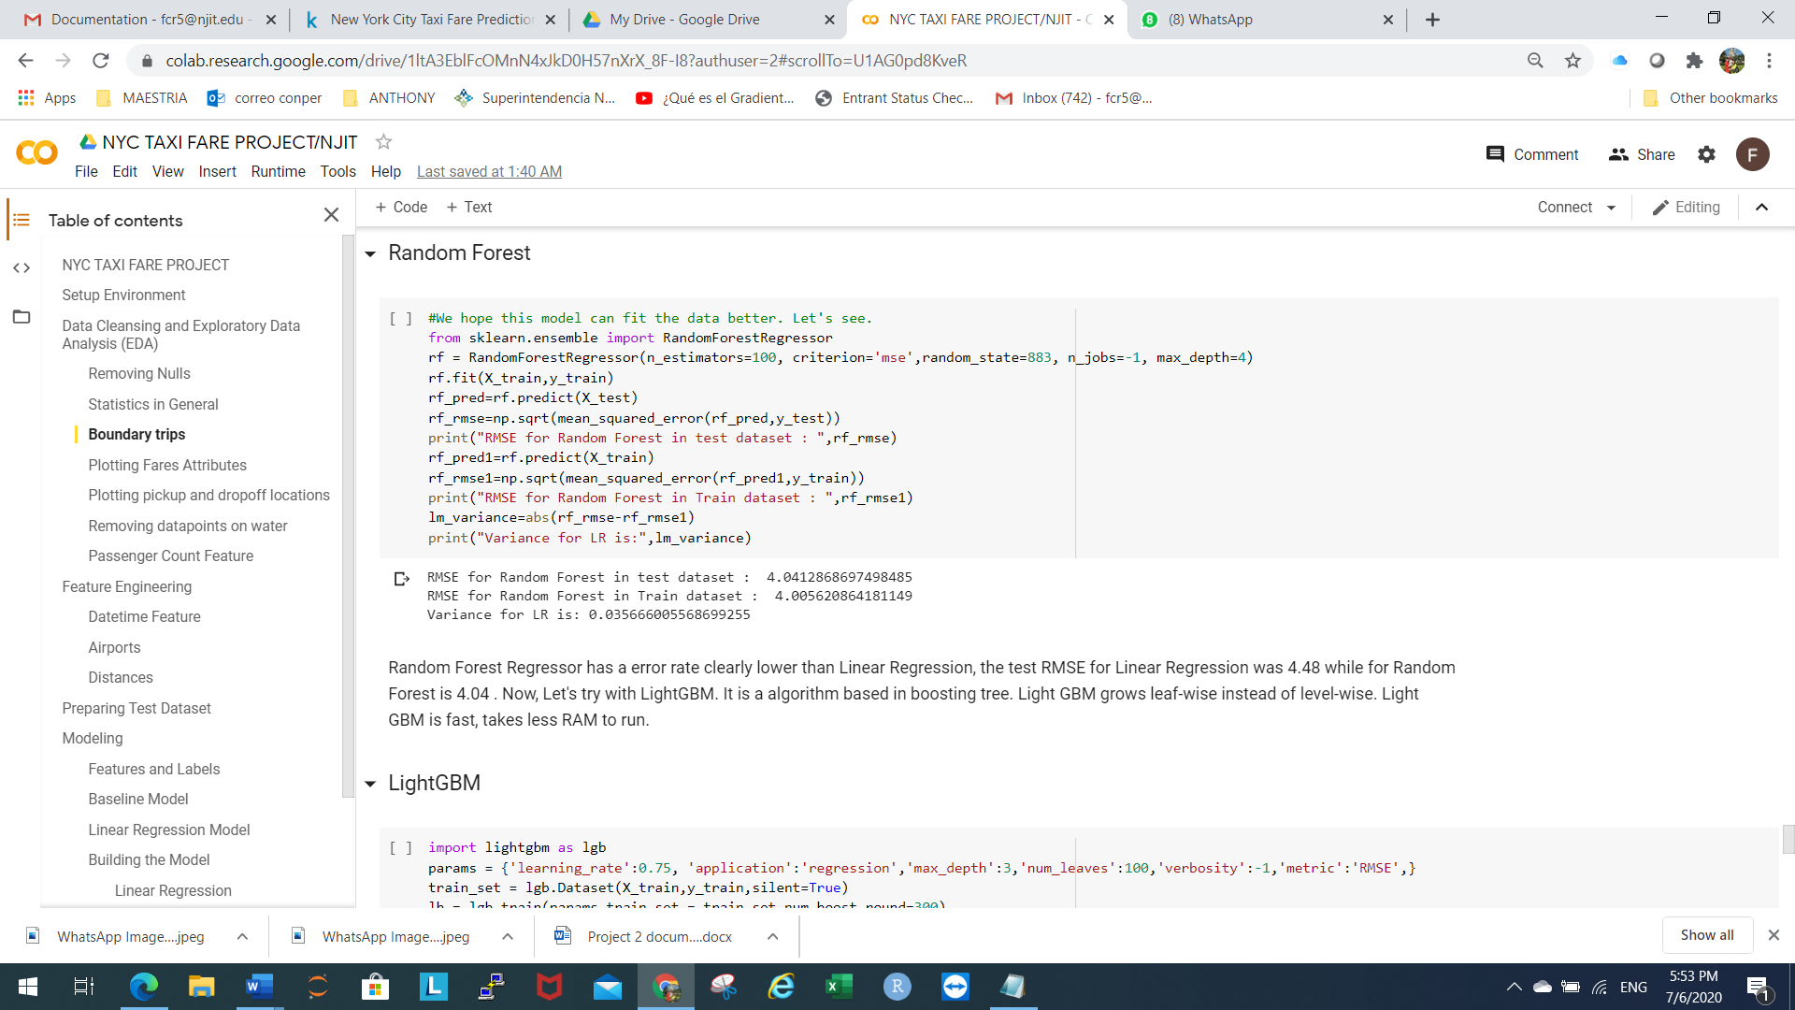

For the random forest algorithm, we an RMSE of 4.04 for the test data and RMSE of 4.00 for the training data. This clearly a noticeable good performance over the linear regression, although is slow.

1. **Light GBM**

This algorithm is boosting tree-based algorithm. This Light GBM tree differs from other tree-based algorithms in that it grows leave wise not a level wise. This algorithm picks a node which will give the maximum delta loss to divide. This algorithm is fast and focuses on accuracy of the results.

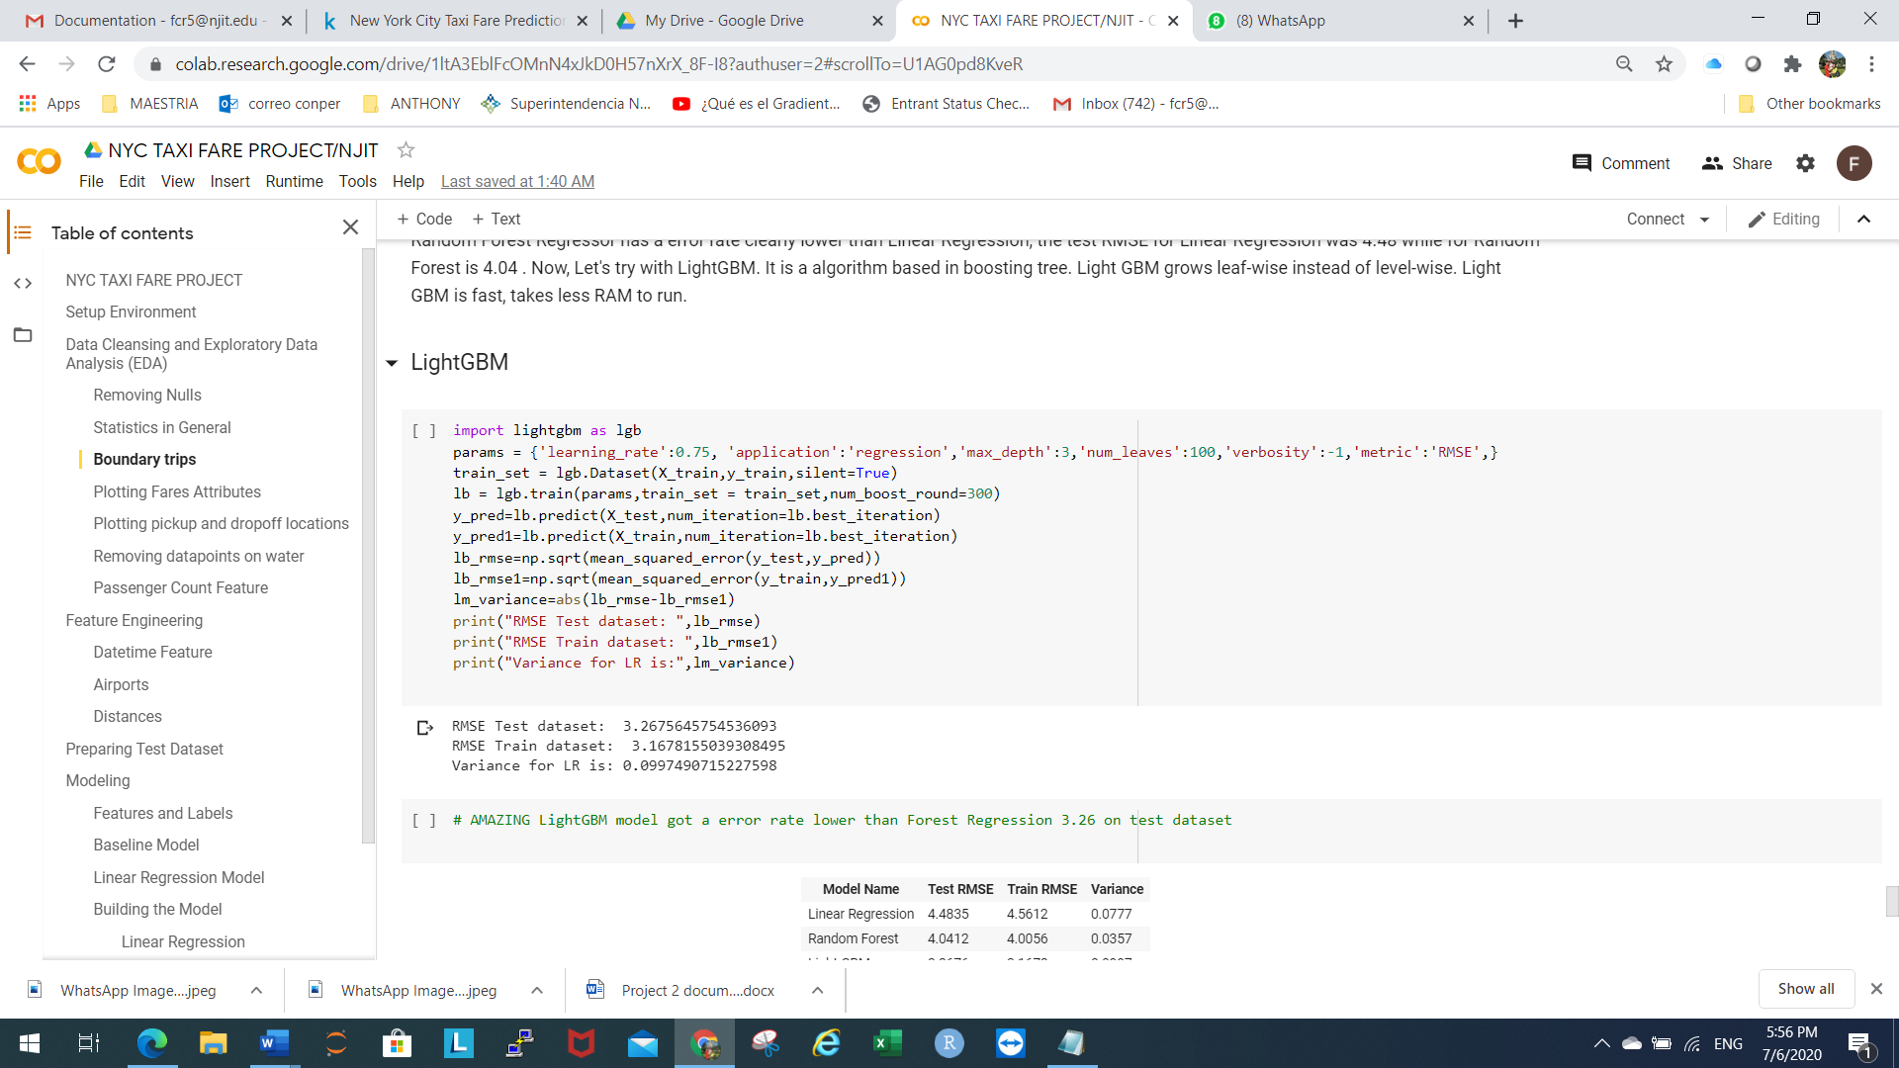

This approach resulted in RMSE of 3.26 for the test dataset and 3.16 for train dataset. This certainly improved over both the linear regression and random forest. The improvement is noticeable!

Here is a summary of the result of all the algorithms.

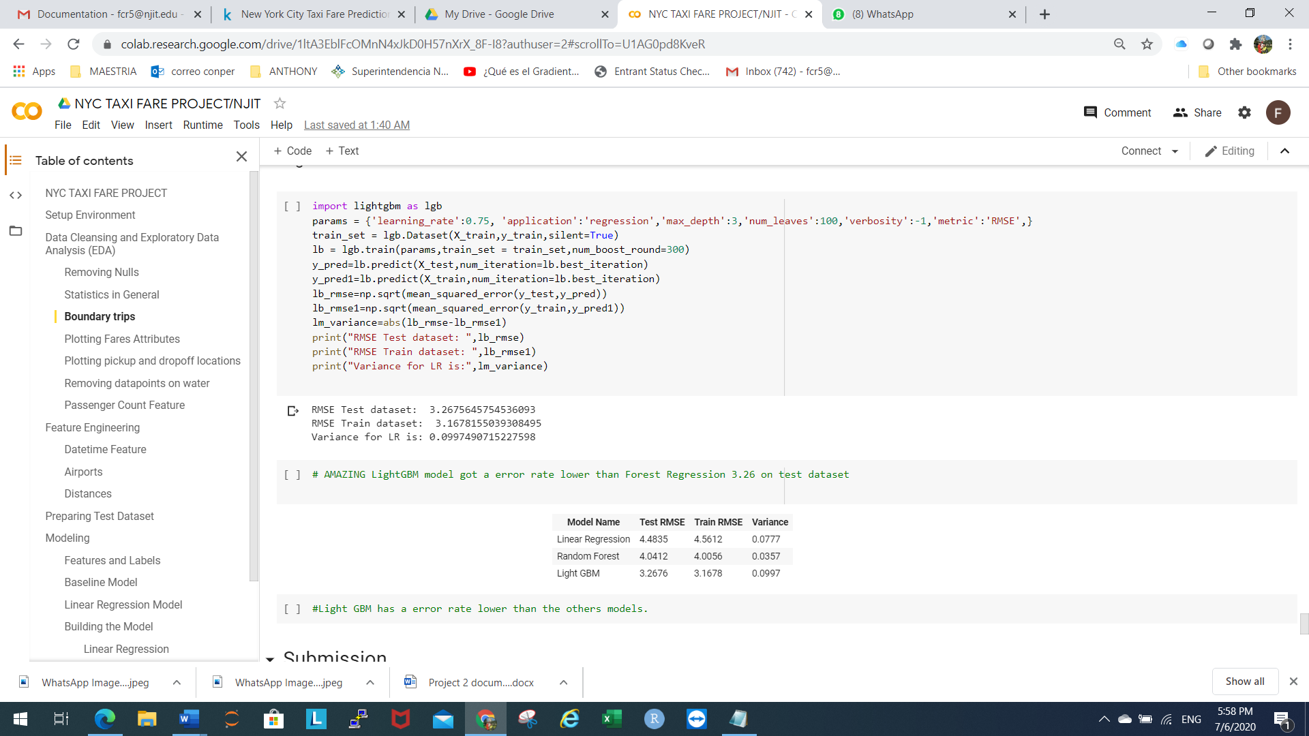

**Part III: Submission**

We should have the same list of columns in test dataset like in train dataset, to predict. Next, create a submission dataframe with key and predictions columns, and the last step is convert DataFrame to CSV File for Kaggle.

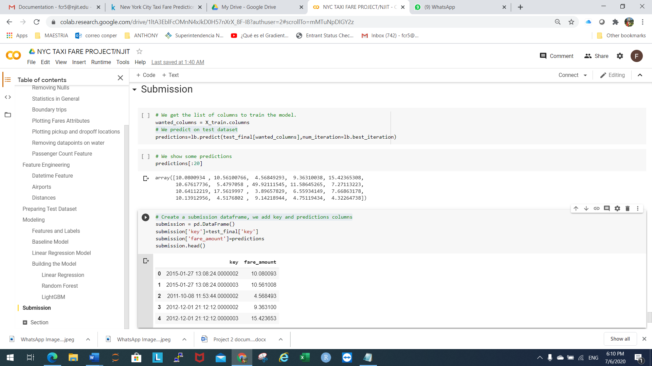

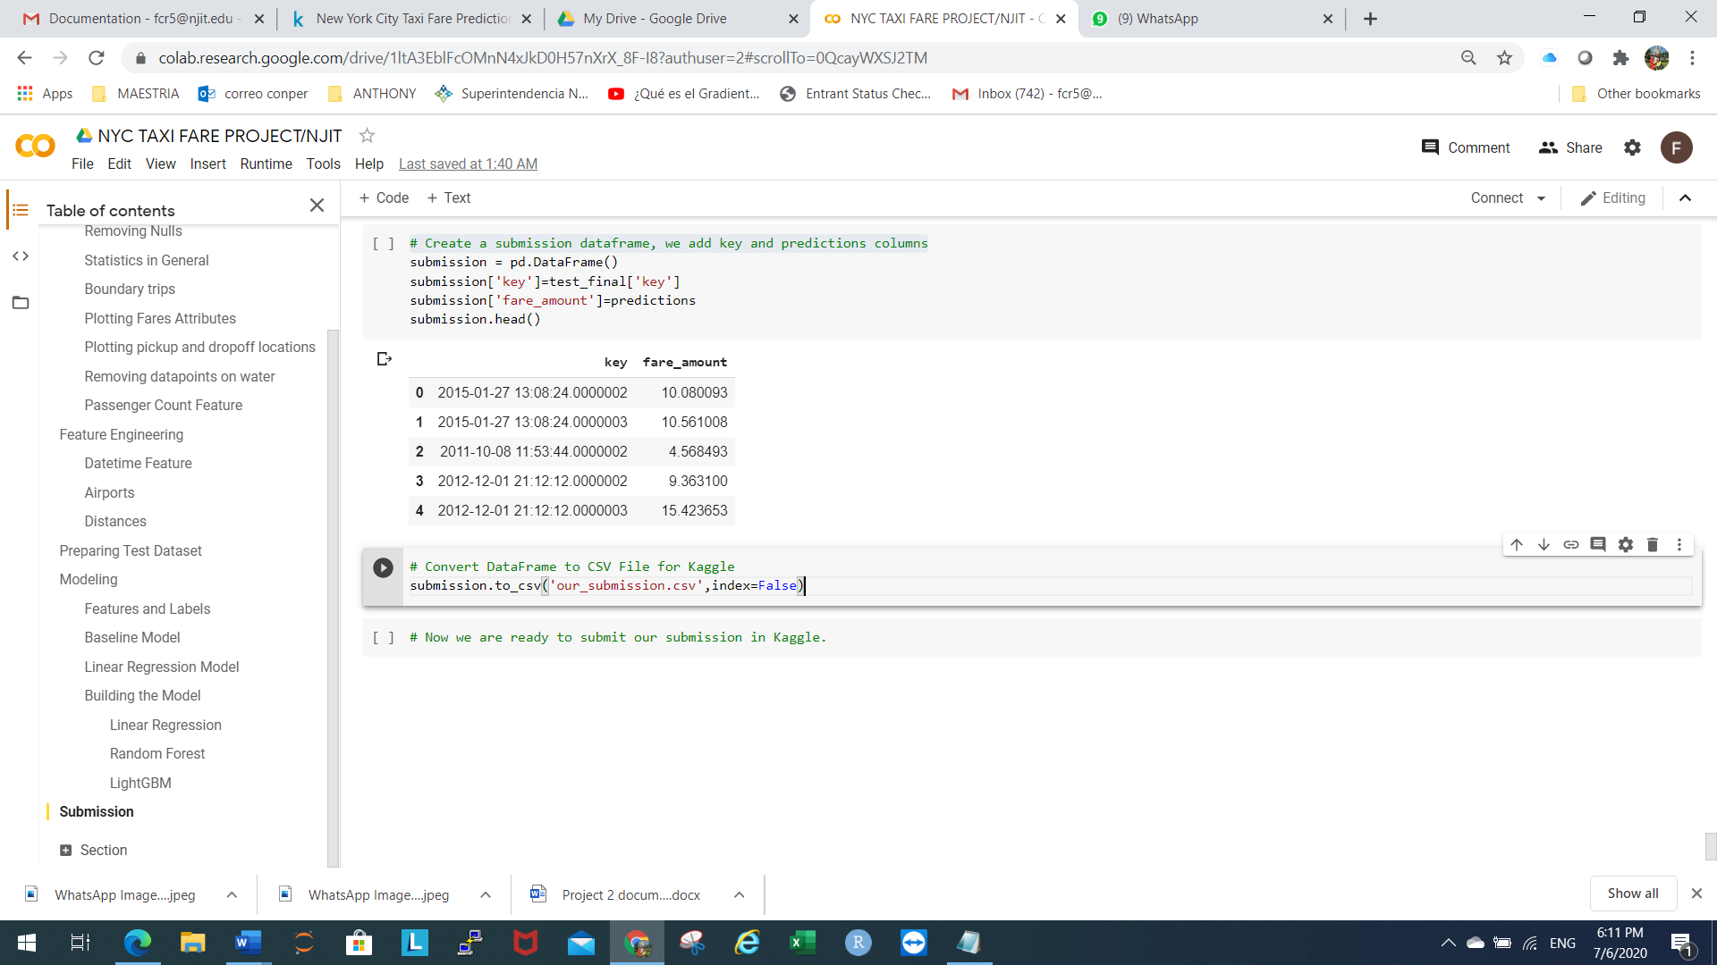

This is a view of our file “our_submission.csv”



Result of submission in Kaggle.



**Conclusion:**

There is still some model tuning left to do and some other improvement to implement to better the predictivity of our models. We can also increase the amount of data used as it could improve accuracy. Having lots of dimensions, we can implement dimensionality reduction techniques it will also factor into getting better accuracy results.